PQMS User’s Guide
This manual is written in reference to main standard manual.
You have to perform following two experiments with the help of PQMS Set Up
- Identification of Magnetic Transition Temperature using AC Susceptibility Measurements.
- Superconductivity using Resistivity Measurements.(Characterization of DC Electrical Resistance of YBCO)

Before performing the experiments you have to be familiar with different components of the cryostat and exchange gas flushing system.
Parts Identification:
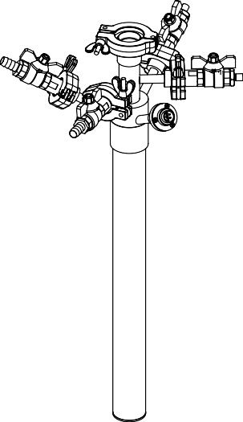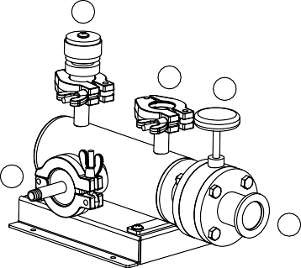
Exchange gas
A
B2
B1
D
C2
C1
E
H
G
F
J
K
I

Figure (a) Side View
Different components of the cryostat and exchange gas flushing system
Sr. No. | Component | Description
1 | A | Sample insertion port.
2 | B1 | Heater chamber evacuation port.
3 | B2 | Heater chamber flushing port.
4 | C1 | Sample chamber evacuation port.
5 | C2 | Sample chamber flushing port.
6 | D | Heater electrical connection feed-through.
7 | E | Cryostate Stand
8 | F | Non-magnetic double-walled cryostat.
9 | G | Pirani gauge mounting port.
10 | H | Release valve.
11 | I | Vacuum pump connection port.
12 | J | Butterfly valve.
13 | K | Cryostat vacuum hose connection port.

Step-1: Create Vacuum in the Sample Chamber and Heater Chamber by following steps
- First, make sure that the sample insert is in the place and all the clamps with their o-rings inside are tightly closed.
- Close all the valves (B1, B2, C1, C2, H and J).
- Switch ON the Rotary Pump (Vacuum Pump).
- Open the Rotary Valve i.e. Butterfly valve J.
- Pump Out both the chambers, Heater Chamber and Sample Chamber by rotating Heater Chamber Evacuation Port B1 and Sample Chamber Evacuation Port C1 at 90⁰.
- Open the Helium Cylinder & Keep the Pressure below 10 psi on the dial gauge.
Step-2: Purging
- Close Heater Chamber Evacuation Port B1 and Samples Chamber Evacuation Port C1.
- Open the Heater Chamber Flushing Port B2 and Sample Chamber Flushing Port C2 for 1 Second only.
- Repeat above two steps 4-5 times.
- Purging is done and now the system is ready for insert the sample (i.e. AC Susceptibility Probe or Resistivity Probe with sample) and cooling with liquid nitrogen.
Experiment 1: Identification of Magnetic Transition Temperature using AC Susceptibility Measurements.


8−pin BNC for coil connection
8−pin BNC
for temperature sensor
KF−25 flange

Sample holder
Susceptometer Coil

Sample
Figure (b) AC Susceptibility Measurement Insert

For AC Susceptibility Measurement first we have to prepare a sample and load it in the cryostat and then we will run the software. Please follow the steps mentioned below:

- First, remove the temperature sensor probe (bnc cable).
- Fill the sample chamber with helium.
- Lose the Sample VSM Motor Screw and keep the Sample Chamber Screw loses.
- Pull the sample chamber road slowly, don’t apply force.
- Now take a small piece of sample (i.e.YBCO or Gadolinium) and wrap it with kapton tape and put this piece inside the sleeve (straw) near to the temperature sensor.
- Fix both end of the sleeve (straw) with kapton tape.
- Insert the sample holder back to the chamber slowly.
- Tight the chamber screw (do not tight too much)
- Tight the VSM motor screw.
- Connect the temperature sensor cord.
- Now fill the LN2 but before filling LN2 evacuate both the chambers and fill the LN2 in cryostat using funnel until it overflows.
- Switch ON all the modules and make the appropriate connections from module to cryostat.
Run the Software QRIUS

- Go to Module Manager>Temp. Controller
- A Dialogue Box will open
- To Set the temperature go to Settings>Linear Ramp Settings>in the dialogue box give the Set Point & Rate>File>Apply>Control Modes>Linear Ramp>Start
- For Gadolinium: Set Point 260 and for YBCO: Set Point 78
- Rate: Max 10K
- If you want to go below room temperature fill the exchange gas in both the chambers otherwise fill only sample chamber.
- After reaching Set Point do the Centering. (Centering is done to find the sample position with respect to two coils).
- For χL Measurement: Go to Magnetic AC Susceptibility>Settings> χL acquisition setting>in the new dialuoge box define the step size>File>Apply>Run Mode> Go to χL>Start
- After getting two peaks finish the run.
- The system will automatically take two peak positions as sample position.
- For χT Measurement: Go to Settings>Temp. Control>Linear ramp setting>set the temp. and ramp rate>start the run>go to run mode> χT linear ramp>start.
- The name of data file and location will be shown in the bottom of the tab automatically.

Experiment 2: Superconductivity using Resistivity Measurements.
(Characterization of DC Electrical Resistance of YBCO)

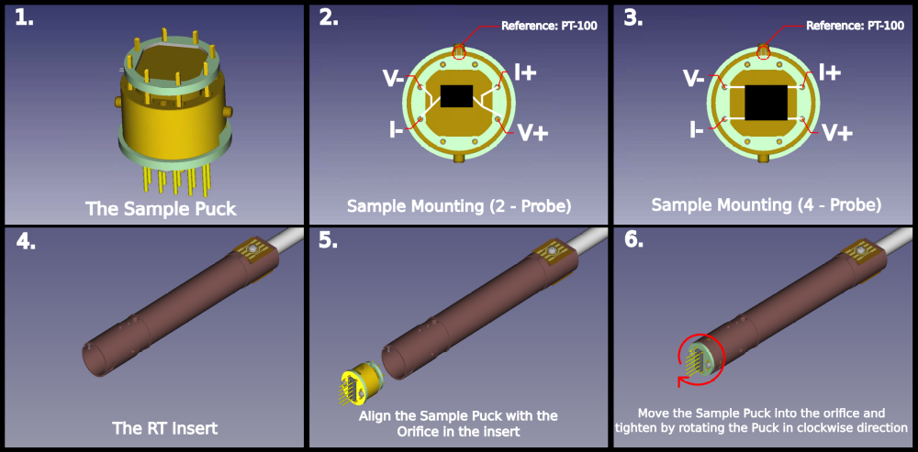

- The YBCO sample mounted on a detachable stage and attached to the R-T Insert.
- R-T insert mounted in quartz cryostat.
- R-T cable and Heater cable should be connected to top of R-T insert and clamped properly.
- Now evacuate the sample chamber by opening the rotary valve.
- When vacuum reaches the maximum then close the rotary valve and purged with Helium gas.
- Repeat the purging process 3-4 times.
- After purging fill the outer chamber with Liquid Nitrogen (LN2) and fill Helium in sample chamber.
- For measuring resistivity wait till sample temperature reaches 80K.
- Now open the QRIUS software.

- First we do Measurement without Magnetic Field
- For Measurement without Magnetic Field: Go to Measurement Mode Settings>Electrical DC Conductivity>Go to Run Mode>R-T (Linear Ramp)>Go o Settings>Temperature Controller> Linear Ramp Settings> Insert the value of required final temperature and ramp rate>File>Apply
- Now start the measurement by clicking start button.
- Data will be showing on the right panel and the measurement stops when the heater temperature reaches the final temperature.

- Now we do Measurement with Magnetic Field
- For Measurement with Magnetic Field: Go to Measurement mode Setting>Electrical DC Conductivity>R-T (Linear Ramp) with H.
- For setting magnetic field: Go to Settings>Magnet Supply (a new tab will open)>File>Connect>Source Parameters>Insert the magnetic field value (maximum field value should be + or – 100 mTesla).
- Go to Settings>Temperature Controller>Linear Ramp Settings>Insert the required Final Temperature and Ramp Rate>File>Apply.
- Start the measurement by clicking start button.
- Data will be showing on the right panel, the measurement stops when the heater temperature reaches final temperature.

NOTE:

[If any module like IV Source or Magnetic Supply etc. not running/not showing connection then go to the particular tab >File>Connect]

[How to save data: Go to main QRIUS window>Sample Settings>Give the Sample Details (i.e. name, id, description)>File>Apply]

